
Kate Byrne, Linda Johnson and Joan Palmer
Join Board of Directors of California Alliance for Arts Education
PRESS RELEASE: Contact: Sibyl O’Malley
May 20, 2014 (626) 578-9315 ext. 102

(Los Angeles, CA) – Emily Hall, Board Chair of the California Alliance for Arts Education, announced today that Kate Byrne, Linda Johnson and Joan Palmer (listed alphabetically) have joined the Alliance’s Board of Directors. The California Alliance is a statewide arts education advocacy organization based in Pasadena and Sacramento dedicated to ensuring that all K-12 public school students have access to the visual and performing arts as part of a complete education.

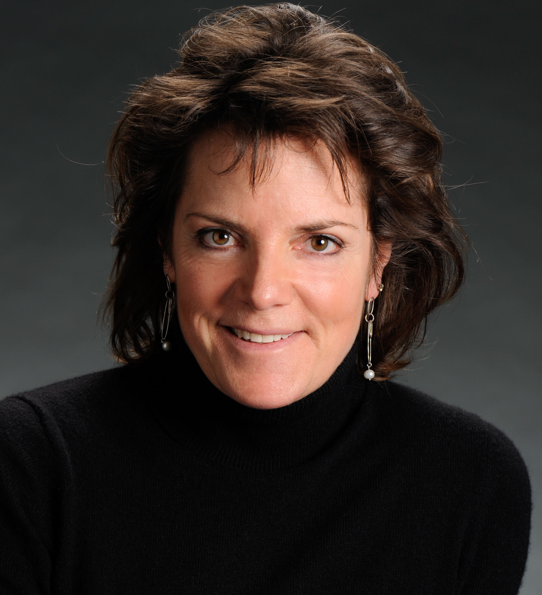
“We are pleased to have Kate Byrne, Linda Johnson and Joan Palmer join us in our efforts to advocate for arts education for all California students,” comments Emily Hall, “They are inspiring leaders, conveners, and champions for the arts who share our commitment to empowering the youth while recognizing the vital role of arts education in our creative economy.”
Kate Byrne has been a leader in the digital media realm for over twenty years. As SVP of Sales/Marketing and Strategy at the San Francisco Chronicle and SF Gate, where she is charged with tapping into the pioneering spirit of the iconic brand and evolving it into a leading player in the digital day of journalism and media platforms. She comes to the Chronicle after having recently served as Chief Growth Officer for World Pulse, where she helped with scaling the 10-year old global digital media platform using digital media to empower and train grass roots women leaders worldwide. She oversaw revenue stream creation, strategic product expansion, partnerships, increasing brand visibility, while aiding in fundraising.
She supports women’s empowerment through Equality and Opportunity Foundation and the Exceptional Women in Publishing organization (EWIP). Byrne has been influential in creative education practices and next generational thinking leading the digital efforts for both the website and the digital magazine edition of Edutopia, the publication and website for the George Lucas Education Foundation. In 2011, she was named to the Folio: 40- a media industry top honor- and recognized as one of the 40 most influential top industry performers. She continues to support education through her work with The Concord Consortium.

Linda Johnson has focused her career on building communities through the arts and ensuring access to high-quality arts education. She is currently Civic Arts Education Manager for the City of Walnut Creek, overseeing a popular regional program that provides community arts education for over 8,000 young people and adults each year. For twelve years prior, she served as executive director of Streetside Stories, a youth arts education organization based in San Francisco that aims to cultivate young people's voices, foster educational equity, and build community, literacy and arts skills. She has served as an advisory board member with Oasis for Girls, and Help a Mother Out. Prior to joining CAAE’s board, she served on the CAAE policy council and took part in local arts advocacy efforts.
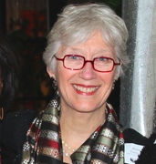
Joan Palmer is a tenacious advocate, whose efforts as a Pasadena Arts Commissioner brought systematic and significant change in the art opportunities offered to all children in Pasadena. She was a board member of the Pasadena Art Workshops and co-chaired the merger, creating the Armory Center for the Arts- adapting the CA National Guard Building into a community resource.
She founded the Pasadena Unified School District (PUSD) Arts Team and served as a chair of Cultural Nexus -- an element to Pasadena’s Comprehensive General Plan (2004) that will advance arts & culture for the next decade. Currently, she serves on the Steering Committee of the School City Work Plan – establishing protocols to streamline educational, social service and health resources among PUSD and the communities it serves. Joan has served previously on the California Alliance board between 2000 – 2009.
For more information contact Sibyl O’Malley, Communications Director, at sibyl@artsed411.org.

