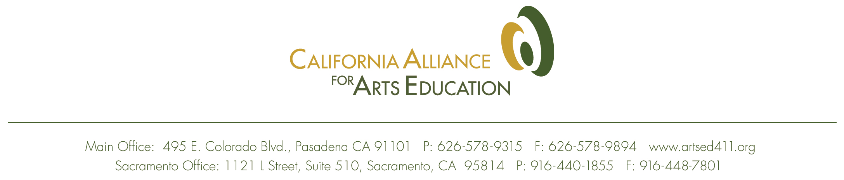 PRESS RELEASE Contact: Laurie Schell
May 20, 2008 (626) 578-9315

Bakersfield Alliance for Arts Education Unites Community Leaders

The Stars Dinner Theater opened its doors extra early on Wednesday, May 14, to host a breakfast meeting of the Bakersfield Alliance for Arts Education. Organized by the California Alliance for Arts Education, and spearheaded by local school board member, Karen Dewalt, the Bakersfield gathering included invited members of business, local government, arts organizations, as well as representatives of Bakersfield’s public schools.
The purpose of the gathering was to establish a core group of local leaders, committed to the principle that arts education is an essential component of a quality education that every child deserves.
“As a school board member and as someone who enjoys being involved in community theater, I’m aware of the important role that arts education plays in the education of our children,” said Dewalt. “Bakersfield has a long history of supporting arts education in our schools, and we’re hoping this local Alliance will build on that support.”
“For some children the arts are the pathway to their educational success,” said Bakersfield School Board member, Lillian Tafoya. “As our communities continue to grow and become more diverse, we need to become more diverse in how we incorporate the arts into our schools.”

Carol Reichert, President of the Bakersfield Elementary Teachers Association observed, “Even though we may have different opinions on lots of other topics, we’re all together on this – the arts are part of a comprehensive education that every child deserves.”

The local effort is the first in a series of pilot projects the California Alliance for Arts Education is sponsoring throughout the state to build upon the momentum created by new state funding to support arts education. In its presentation, the Alliance cited evidence of the benefits students draw from arts education, both in their engagement and performance in other aspects of school, as well in developing the skills required in the workforce of the 21st century, which include innovation, creativity, collaboration, and discipline.

Concern was expressed over the impact that the federal “No Child Left Behind” program has had on access to arts education for many students. Dr. James Fillbrant, former Assistant School Superintendent and current Executive Director of the Bakersfield Musical Theater pointed out, “ What’s hurting the arts in high schools is the emphasis on basic skills – two to four times a day. High schools are so squeezed by tests, and the students who would benefit most from the impact of arts education are forced to sit in basic classes.”

Presentations on the state of arts education in local schools were made by Visual and Performing Arts Coordinators, Mike Stone (Bakersfield City) Dennis Herbst (Panama Buena Vista), and Kathleen White (Kern County Office of Education).

Various ideas for promoting arts education in Bakersfield schools were discussed by the group, including making some arts education background a priority in hiring new teachers, building a survey for school board candidates that includes questions about arts education, and including arts education goals within performance reviews for principals. In the coming year the Bakersfield Alliance may unite around efforts to support arts education funding both at the statewide level with elected officials in Sacramento, and locally, at school board meetings.
Elected officials and business leaders in attendance included City Councilman Ken Weir, representatives from Congressman Kevin McCarthy and Assemblymember Jean Fuller, and Lou Gomez, President/CEO of the Hispanic Chamber of Commerce.
Executive Director of the California Alliance, Laurie Schell, observed, “The Alliance recognizes the unique opportunity that exists in California to build upon the momentum created by the historic investment of state funds for arts education during the past two years. It is the intent of this funding to help implement a comprehensive vision for arts education at the local level.”

Dennis Herbst seemed to capture the passion of the group in his observation that “The arts are like an indigenous weed – they try to beat us back – but somehow we find a crack in the concrete – we’ll write a poem, tell a story, draw a picture, play a song. We love what we do and we want to share that with the world.”

To learn more about what you can do to support arts education in your school, visit the website of the California Alliance for Arts Education at www.artsed411.org

CAAE is the only statewide organization that brings together all primary constituencies for arts education, annually serving over 100,000 arts organizations, K-12 teachers, professional teacher associations, state and local education departments, professional development providers, parents and PTAs, and interested community members in higher education and business. Our shared mission is to promote, support and advocate visual and performing arts education for preschool through post-secondary students in California schools.

